
NEWS FROM NG2

DANISH PARTNERSHIP

Nottingham Forest have forged a partnership agreement with Danish side B1913. The two clubs will pool their resources at Academy level in a deal that could lead to Forest signing rising stars from Denmark in years to come.
6
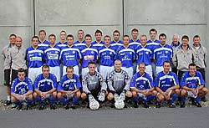
Academy Director Nick Marshall explained: "Myself and Paul Hart were invited to visit B1913 three years ago and were impressed by the youth set-up at the club. They play in the First Division in Denmark but are not what you would regard as a big club. However, they have had a lot of success in terms of bringing young players through into their team. And what's more, a lot of their youngsters have gone on to make their mark elsewhere in Denmark, as well as in other parts of Europe. As part of the agreement we've reached with B1913, we will send our coaches over there to do some coaching and they will send some of their players over to us so that we can have a good look at them. "And hopefully, in the long term, one or two of their youngsters could end up signing for Nottingham Forest." Marshall added: "It gives us another niche. Our number one priority is still to develop players from in and around Nottingham. But we will be delighted if we come across a top-class player in Denmark who wants to play for us."
Forest's players are using an innovative new heat pad to speed up their injuries. Physios John Haselden and Gary Fleming have worked with Rotherham-based Inditherm plc to develop the equipment called speedheat. Haselden explained: "Normally heat is given by a lamp, heat packs or hot water which are inconvenient at times and take a lot of setting up. Once the appliance is on, the heat goes away. "This new pad maintains the heat. We can control the temperature and keep it at a certain temperature right through the length of the treatment. "It's an ideal situation. The fact the players can move around with this and move their joints or muscles makes it so easy to use. "We can take it away with us on trips to matches or pre-season tours so it is very adaptable and user-friendly." The physios have been testing out the equipment over the last two months, making the necessary alterations to develop the product. Haselden added: "It's a very convenient way of helping muscle joints. We can localise to whichever spot is necessary and it is also good for people with arthritis."
LIVE FOOTBALL AT THE PITCH DINER
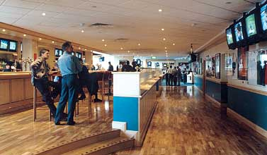
Are you in Nottingham on the following dates?
Sat 29 Mar - Liechtenstein v England – Kick Off 6.30pm
Mon 31 Mar - Leicester v Forest – Kick Off 7.45pm
Wed 2 Apr - England v Turkey – Kick Off 7.45pm
If so they why not go along and watch the game in the Pitch Diner at the City Ground. Entry is free and there is no need to book. Bar opens one and a half hours before Kick Off for each game.
LATEST FIXTURE INFORMATION
Leicester City (Away) now on Tuesday 8 April 2003 at the Walker’s Stadium.
Sheffield United v Forest. Rearranged for Tue 15 Apr at Bramall Lane Kick Off 19:45.
Charlton Reserves v Forest Reserves ‘provisionally’ rearranged for Wed 16 Apr at the Valley kick-off 19:00.

